SOFTWARE REQUIREMENT SPECIFICATION (SRS)

TUITION MANAGEMENT SYSTEM

2015

MIND’S GOLDEN SDN BHD

To be submitted to the Software Planning & Requirement Workshop

Bachelor of Computer Science (Software Engineering)

# DOCUMENT APPROVAL

**Group Members : Student ID**

Muhammad Aizuddin Bin Nor Hazmi CB14004

Nur Shahirah Binti Muhammad Zully CB14033

Nik Hasnie Binti Nik Soh CB14131

Zulaikha Binti Zuremi CB14135

Nazira Binti Azman CB14041

|  |  |  |
| --- | --- | --- |
|  | **Name** | **Date** |
| **Authenticated by:**  _______________________  Project Manager | Muhamad Aizuddin Bin Nor Hazmi |  |
| **Approved by:**  _______________________    Client | Mohd Kamizi bin Haji Zainal |  |

Software : Microsoft Word 2013, Rational Software Architecture

Archiving Place : https://drive.google.com/open?id=0B6cX-pGT6XMzREtiLVNsTnhqT0E

Copies Available : 1

# TABLE OF CONTENTS

DOCUMENT APPROVAL 2

TABLE OF CONTENTS 3

LIST OF FIGURES 5

LIST OF TABLES 6

LIST OF APPENDIXES 8

1. INTRODUCTION 9

1.1 PURPOSE 9

1.2 SYSTEM IDENTIFICATION 9

1.3 SYSTEM OVERVIEW 10

1.4 PROBLEM STATEMENT 12

1.5 REFERENCES 14

1.6 DOCUMENT OVERVIEW 15

2. PRODUCT DESCRIPTION 14

2.1 BUSINESS PROCEDURE 15

2.2 SYSTEM REQUIREMENT 16

2.3 SYSTEM BOUNDARY 17

2.4 SYSTEM INTERFACE 18

2.5 SYSTEM FUNCTION 19

2.6 SYSTEM CONSTRAINTS 20

2.7 ASSUMPTIONS AND DEPENDENCIES……………………………………….......21

3. SPECIFIC REQUIREMENTS 22

3.1 SOFTWARE PRODUCT FEATURE 22

3.2 USER INTERFACE REQUIREMENT 50

3.2.1 GRAPHICAL USER INTERFACE 52

3.2.2.HARDWARE INTERFACE 57

3.2.2.SOFTWARE INTERFACE 57

3.3 REQUIREMENT TRACEABILITY…………………………………………………….58

4. ACRONYMS AND ABBREVIATION 61

# LIST OF FIGURES

# Figure 1.1: Show BPM for the Tuition Management System 11

# Figure 2.1: BPM for the Tuition Management System 14

# Figure 2.2: System boundary for Tuition Management System 17

# Figure 2.3: Use case diagram for Tuition Management System(Kite Level) 19

# Figure 3.1: Use Case for Finance Module 22

# Figure 3.1.1: Decompose Use Case Finance Module 23

# Figure 3.1.1.1: Use case for Get Fees Detail 23

# Figure 3.1.1.2: Use case Get Payment 24

# Figure 3.1.1.3: Use case Order Book 25

# Figure 3.2: Use case Teaching Material 27

# Figure 3.2.1:Decompose Use case Manage Teaching Material 27

# Figure 3.3: Use Case Manage Registration 34

# Figure 3.3.1: Decomposte Use case for Manage Registration 34

# Figure 3.4: Use Case Student Performance 40

# Figure 3.4.1: Decomposte Use Case Student Performnce Module. 40

Figure 3.5: Use Case Manage Attendance 45

Figure 3.5.1: Decomposte Use Case Manage Attendance 45

Figure 3.6: Diaglog Diagram For Tuition Management System 51

Figure 3.7: System Interface 53

# LIST OF TABLES

# Table 2.1: System requirement for Tuition Management System 15

# Table 2.2: List of system context 17

# Table 2.3: List of actor 18

# Table 3.1: Get Fees Detail 24

# Table 3.2: Get Payment Detail 25

# Table 3.3: Ordering Book 26

# Table 3.4: Manage Note. 28

# Table 3.5: Manage Exercise 29

# Table 3.6: Manage Online Quiz 30

# Table 3.7: Get Notes 31

# Table 3.8: Get Exercise 32

# Table 3.9: Get Quiz Online 33

# Table 3.10: Use Register System User 35

# Table 3.11: Use Case Register Student Subject 36

# Table 3.12: Use Case Assign Teacher Subject. 37

# Table 3.13: Use Case Enter Subject Offers 38

# Table 3.14: Use Case View Schedule 39

# Table 3.15: Use Case Manage Manage Student Comment 41

# Table 3.16: Use Case Manage Student Result 42

# Table 3.17: Use Case View Result 43

# Table 3.18: Use Case Print Result 44

Table 3.19: Use Case View Attendance 46

Table 3.20: Use Case Calculate Working Hours 48

Table 3.21: Use Case Manage Worning Letter 49

Table 3.22: Description of User Interface Components 52

Table 3.23: Traceabilityy for Matrix A 58

Table 3.24: Traceability for Matrix B 60

# Table 4.1: Acronyms and abbreviation 61

LIST OF APPENDIXES

1. APPENDIX A Activity Diagram
   1. Appendix A1 Activity Diagram for Financial Module
   2. Appendix A2 Activity Diagram for Teaching Module
   3. Appendix A3 Activity Diagram for Registration Module
   4. Appendix A4 Activity Diagram for Student Performance Module
   5. Appendix A5 Activity Diagram for Attendance Module

1. INTRODUCTION

## 1.1 PURPOSE

The purpose of this document is to present the details description of the Tuition Management System. These document explained the purpose and features of the system, the interfaces that being used, what the system can do, the constraint under which it must operate and how the system will react to external stimuli. This document is intended for both the stakeholders and the developers of the system of the system.

## SYSTEM IDENTIFICATION

System Title : Tuition Management System

System Abbreviation : TMS

System ID : TMS-2015-01

The purpose of TMS is to help user to manage the tuition center in many aspect. TMS offer new functionality and features to existing system. TMS can be used easily to the user and can be accessed by all categories. System identification number for this project is TMS-2015-01.

ID for use case : UC - <module name> - <sequence number)

eg. UC-RM-01

where UC refer to “use case”, RM refer to “registration module” and 01 is it “sequence”.

ID for system requirement : SR - <module name> - <sequence number>

eg. SFR-TM-01 / SNR-TM-01

where SFR refer to “system functional requirement” or SNR refer to “system non-functional requirement” , TM refer to “teaching module” and 01 is it “sequence”.

## SYSTEM OVERVIEW

Tuition Management System is a web-based system that will be used in tuition centre. This system is basically specializing on managing a tuition centre. This system is handled by staff and top management to manage on registration, teaching module, finance, attendance and students performance. In addition, this system has the user that holds the responsibilities who we called admin to assigned and maintain the detail of staff, student, subject and payment. While the other staff only have responsibilities on registering and maintain the detail of student, payment and subject.

This system can keep huge data organized, secured and may reduce the uses of lots of paper. There are five modules to be developed in order to complete this TMS system. There are registration module, finance module, student performance module, teaching module and attendance module. This system will use computerized system to key in any information which will reduce the inefficient way that is currently being used where from using paper to using computerized system that used database.

In our project, there are five main module as you can see in diagram, which is registration module, teaching module, student performance module, finance module and attendance module. First of all, user needs to login before use those modules, except for registration module in part of student registration.

In registration module, the new student will register into the system. Finish that, student will be brought to log in interface to log in to the system using given username and password. After any user log in the system, student and teacher can register subject as student register subject to take and teacher register subject to teach the student. Teacher registration and staff registration will be managed by admin. They will log in to the system using given username and password before they can change their own password.

In teaching module, they will be managing teaching material which will be managed by lecturer in their own interface. Teacher will add, modified or delete any teaching material which they think suitable for the student. For the student, they can retrieve the teaching material that had been managed by teacher. Student can view, print or download the teaching material from this module. Then, the student or teacher can make any forum discussion about any subject. Any announcement for the student will be managed by teacher or staff.

In student performance module, student can view the result of their test or quiz. They also can view the graph of their performance. They student result will be manage by teacher who will key in the mark of the quiz or test to the system. System will calculate the student performance automatically. Any student performance will be notified to the student’s parent.

For the finance module, the system will calculate the student fees based on the subject taken and what type of class or section they take. In this module, the system will also calculate the staff and teachers payment based on their subject teach, attendance and class or section taught. Any kind of payment will be print out as prove.

Lastly is the attendance module. The attendance module will record the student, teachers and staff attendance. The entire subject taken by the student will have its own attendance sheet. So the student has to attend all the class they take. The same concept is applied to the teacher. The entire user will get warning letter when absent more than 3 times. It means, if student and teachers absent 3 times for the same subject, they will get a warning letter. But for the staff, if they do not attend without a letter 3 times, they also will get warning letter.



Figure 1.1 Show work breakdown structure for TMS

**1.4 Problem Statement**

There some problem with the existing manual system which sometimes can be trouble for the user.

1. Data loss happen in existing manual system which sometimes troubling the user. Existing manual system is using paper to store the information of the tuition centre either the information of the staff, teacher, student or the payment made and others. The risk of information loss is due to the misplaces of the paper, loss of the paper. Sometimes, the tuition centre could be upgraded or move to another location, so any information regarding all of that could be loss in the process of move or upgrading the place.

2. Retrieving or searching the data using existing manual system could take several minutes or hours due to search from file to file. Sometimes the staff or teachers forget about the place where they save the document. So it could take time to remember back the location or time for them to search the document. This situation leads to waste of time.

3. Student can only get teaching material such as note or reference from teacher during the classes. Student can access or get the teaching material from home if they did not take it during the class. It could be trouble for the student since they could forget to ask the teacher for it during class.

## 1.5 REFERENCES

1. ISTBQ Exam Certification. (2015). What is RAD model- advantages, disadvantages and when to use it? Retrieved from: <http://istqbexamcertification.com/what-is-rad-model-advantages-disadvantages-and-when-to-use-it/>
2. Haryani Bt Ibrahim, (2007). Tuition Management System. Retrieved from : <http://library.utem.edu.my/index2.php?option=com_docman&task=doc_view&gid=3050&Itemid=208>
3. Susan Weese. April 9, 2012. Identifying Project Assumption and Constraint. Retrieved from: <http://blog.learningtree.com/identifying-project-assumptions-and-constraints/>

## 1.6 DOCUMENT OVERVIEW

This Software Requirement Specification document has 4 different parts which the part is introduction, product descriptions, specific requirements and acronyms and abbreviation.

The purpose of this document by chapter is to outline the entire requirement that has been gathered for the Tuition Centre. In the first chapter, the system identification of this system has been stated. Then the overview for this system are stated all module that will be implemented in the system with detail. The reference that we refer also stated as prove.

In product description or chapter 2, the business procedure models are implemented. This show the workflow for our system. The outline the entire requirement that has been gathered for the Tuition Centre. TMS will be built on Apache, PHP and MySQL using the implementation phase. System requirement stated in this document to show the functional and non-functional for this TMS. The lists of actor are list out to make sure the requirement can be reach. This chapter is more to system. The people that will use the system, system function, the system constraints and the assumptions and dependencies. This to make sure that the client can be able to understand the system flow and the weakness of system. System function show the work that can be done in the system boundary. The assumption and dependencies are stated to make sure that when the system failure, it easier to we refer.

For specific requirement in chapter 3, this will able to let the client know the more detail about this system. The client can know more about the product features, the interface requirements and the requirement traceability. Then, these documents represent the details about the software and the system that will be developing using the requirement gathered.

Last chapter was implemented with the acronyms and abbreviation that will be useful to the client that do not able to understand with the short form.

**2. PRODUCT DESCRIPTION**

**2.1 Business procedure**

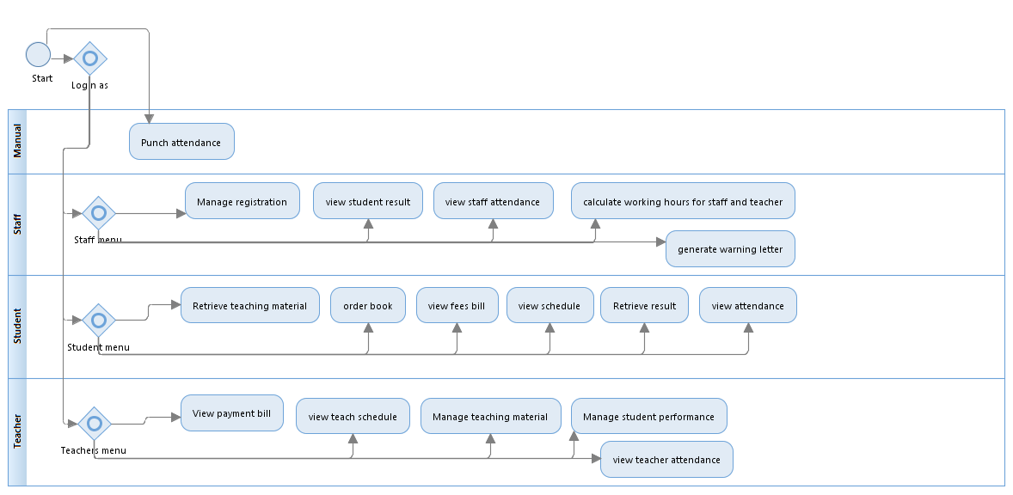

Figure 2.1 BPM for the Tuition Management System

### 2.2 System Requirements

**Table 2.1: System requirement for Tuition Management System**

|  |  |
| --- | --- |
| SFR-RM-01 | Administrative staff should register new student, new staff and new teacher. |
| SFR-RM-02 | Administrative staff should register subject for teacher depend on their job scope. |
| SFR-RM-03 | Administrative staff should register student’s subject. |
| SFR-RM-04 | Administrative staff should enter subject to offer or open for the student to take. |
| SFR-RM-05 | Teacher can view their schedule. |
| SFR-RM-06 | Student can view their daily schedule in tuition centre. |
| SFR-TM-01 | Teacher should add, edit or delete note to the system. |
| SFR-TM-02 | Student should retrieve note with viewing it, download it or print it. |
| SFR-TM-03 | Teacher should add, edit or delete any exercise necessary. |
| SFR-TM-04 | Student should access exercise made by the teacher in the system. |
| SFR-TM-05 | Teacher should create online quizzes in the system. |
| SFR-TM-06 | Student should access online quizzes made by the teacher. |
| SFR-AM-01 | Student can view their attendance. |
| SFR-AM-02 | Teacher can view their attendance. |
| SFR-AM-03 | Staff can view their attendance. |
| SFR-AM-04 | Administrative staff should calculate working hours of the staff and teacher. |
| SFR-AM-05 | Staff can generate warning letter for student who absent more than 3 days without notice. |
| SFR-PM-01 | Teacher should comment to the student performance or result. |
| SFR-PM-02 | Student can view comment made by teacher on their result. |
| SFR-PM-03 | Teacher should add, edit or delete student result for quiz or examination. |
| SFR-PM-04 | Teacher can view student’s result. |
| SFR-PM-05 | Staff can view student’s result. |
| SFR-PM-06 | Student can view their result. |
| SFR-PM-07 | Student can print the result. |
| SFR-FM-01 | Student can view the fees bill. |
| SFR-FM-02 | Teacher should view payment bill. |
| SFR-FM-03 | Student can make book ordering. |

## 2.3 System Boundary

The system boundary shows the outside system and outside actor that get involve making the system success. The table show the system and actor that get involve:

**Table 2.2: List of system context**

|  |  |
| --- | --- |
| **System Contex** | **Description** |
| ATM System | Lecturer use the system to take their payment and student will use to pay fee to tuition center. |
| Punch Attendance System | Lecturer and staff will use this system to update their attendance. |
| Supplier | People that interact with staff to take order book. |

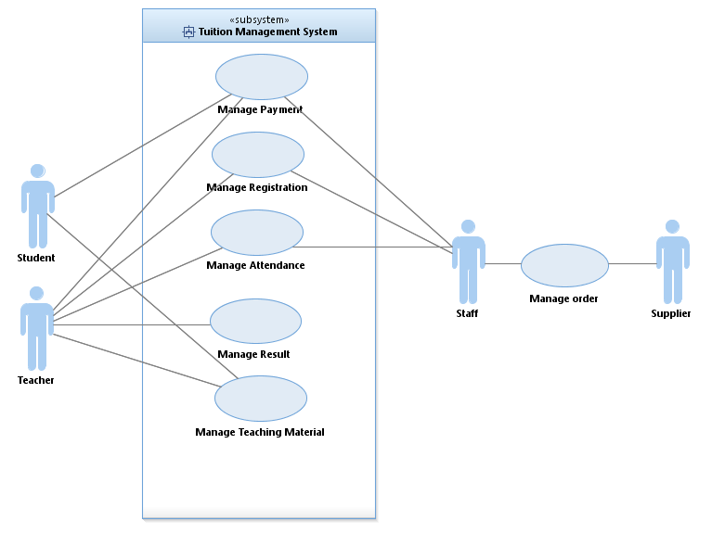

Figure 2.2: System boundary for Tuition Management System

## 2.4 System Interface

**Table 2.3: List of actor**

|  |  |
| --- | --- |
| **ACTOR** | **Description** |
| **Staff** | Staff in Minds Golden.Sdn Bhd that were manage the salary teachers.There are several purpose for staff use this system.   * Payment teacher. * Attendance * Registration student and teacher. * Student result. |
| **Teacher** | Person who teach in class at Minds Golden Tuition. He/She will do the teaching task.There is purpose for teacher to use this system :   * Attendance * Give feedback * Uploads notes at the portal**.** * Key in mark for assessment |
| **Student** | Person who attend class tuition in Minds Golden Tuition.There is several purpose student use this system :   * Register subject. * Order book. * Attendance. * Display result. |

## 2.5 System Function

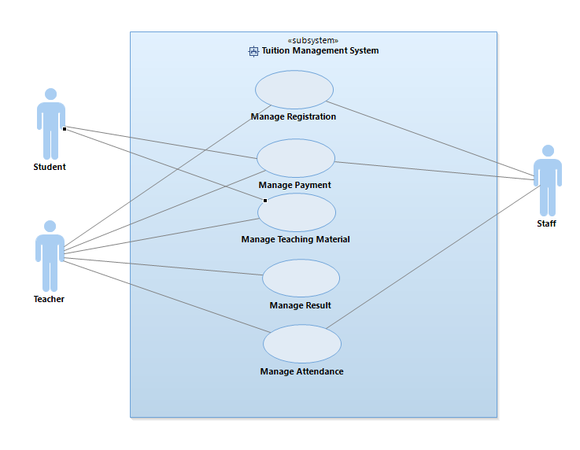

Figure 2.3: Use case diagram for Tuition Management System(Kite Level)

## 2.6 System Constraints

The sub-section below will explain briefly the constraints that consider when the development of this project is done.

1. The user already has experience with other similar system. So, Member expectation for this system may differ and have high expectations of performance.
2. The robustness to recovery page takes 10 seconds.
3. The Internet connection is also a constraint for the application. Since the application fetches data from the database over the Internet, it is crucial that there is an Internet connection for the application to function.

## 2.7 Assumptions and Dependencies

There are several assumptions and dependencies that provided in our system :

Assumption

1. The data that admin, lecturer and student insert in the system are secure. The data are private and protected from other except for the system user.
2. System web are compatible view with Google chrome and Mozilla Firefox .
3. Each user has their account and no one can access the other’s accounts.
4. The system will connect to the database.
5. The system allow user to make registration.

Dependencies

1. The system is secure with network that implement with firewalls, running antispyware and virus detection programs on servers and network-addressed storage systems.
2. Provided information to each customer to turn on their compatible view with using developer tools.
3. The login parts are useful to make sure that each user only can access their account.
4. Network should always be applied.
5. The registration can be done when the network are applied.

# 3. SPECIFIC REQUIREMENTS

## 3.1 Software Product Features

### 3.1.1 Finance Module Use Case.

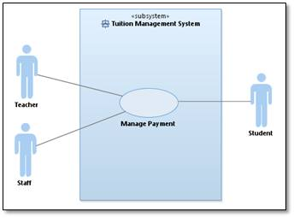

Figure 3.1 : Use case for Finance Module

This use case diagram shows the actors that use the sub system in the TMS. Teacher will involve in get payment detail. In the use case, teacher can view their payment and print the bill. The student use the get fees detail to view their fees and print the bill. Student also can make ordering book using the system.

### 

Figure 3.1.1: Decomposed Use Case Financial Module

Then, each use case (at sea level) in Figure 3.1.1 are describe in Table 3.1, Table 3.2 and Table 3.3.

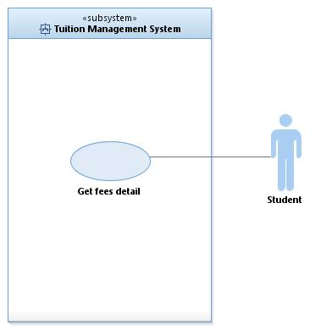

**Figure 3.1.1.1 Use case for Get Fees Detail**

**Table 3.1 Get Fees Detail**

|  |  |
| --- | --- |
| **Use Case ID** | UC-FM-01 |
| **Brief Description** | This use case is use to view student fees and print the bill. |
| **Actor** | Student |
| **Pre-Conditions** | Login into the system and ‘Finance’ button is clicked. |
| **Basic Flow** | 1. Student will see the detail of their fees such as their class, subject and ordering book. 2. Student is allowed to click the print button to print the fees bill. |
| **Alternative Flow** | 1.User click the print button  A) User clicks the print button to print the bill.  B) The bill will generate. |
| **Exception Flow** | - |
| **Post-Conditions** | 1. The bill successful to print. |
| **Rules** | - |
| **Constraints** | Need to check the internet connection |
| **Activity Diagram** | Refer Appendix A  A1 Activity Diagram for Financial Module |

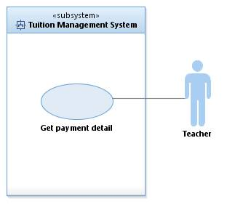

Figure 3.1.1.2: Use Case for Get Payment

**Table 3.2 Get Payment Detail**

|  |  |
| --- | --- |
| **Use Case ID** | UC-FM-02 |
| **Brief Description** | This use case is use to view payment and print the bill |
| **Actor** | Teacher |
| **Pre-Conditions** | Login into the system and ‘Finance’ button is clicked. |
| **Basic Flow** | 1. System will send the attendance of each teacher. 2. The system will automatically calculate the payment. 3. Teacher will see the payment info. 4. Teachers allow clicking the print button to print the bill. |
| **Alternative Flow** | 1.User click the print button  A) User click the print button  B) The bill will generate |
| **Exception Flow** | - |
| **Post-Conditions** | 1. The bill successful to print. |
| **Rules** | - |
| **Constraints** | Need to check the internet connection |
| **Activity Diagram** | Refer Appendix  A1 Activity Diagram for Financial Module |

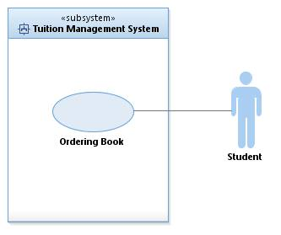

Figure 3.1.1.3 Use Case for Ordering Book

**Table 3.3 Ordering Book**

|  |  |
| --- | --- |
| **Use Case ID** | UC-FM-03 |
| **Brief Description** | This use case is use to make ordering book |
| **Actor** | Student |
| **Pre-Conditions** | Login into the system and ‘Finance’ button is clicked. |
| **Basic Flow** | 1. Student will see the list of book.  2. Student is allowed to select the book that they want to order.  3. After select the book, student should click the send button to send the book list.  4. The system will update the price inside the student fees. |
| **Alternative Flow** | 1.User click the send button  A) User click the send button  B) The price of book will update inside the student fees |
| **Exception Flow** | 1.Invalid input  A) The system will display select the book.  B) User has to select the book again.  C) User should click the send button to send the list. |
| **Post-Conditions** | 1.The list of book is successful send. |
| **Rules** | - |
| **Constraints** | Need to check the internet connection |
| **Activity Diagram** | Refer Appendix  A1 Activity Diagram for Financial Module |

### 3.1.2 Teaching Module Use Case.

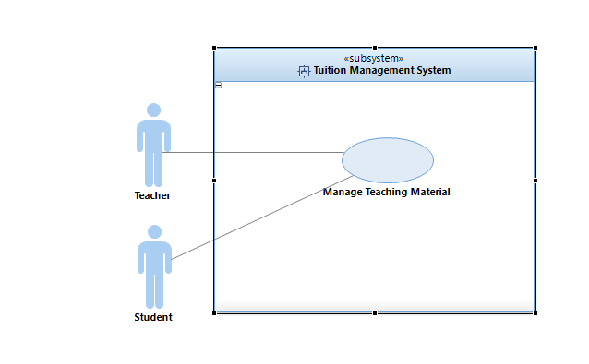

Figure 3.2 : Use case for Teaching Material.

This use case diagram shows the actors that use the sub system in the TMS. The actor use the manage teaching material such as student will retrieve the notes from the system. The teacher will use the manage teaching material to upload the notes, exercises and open online quiz.

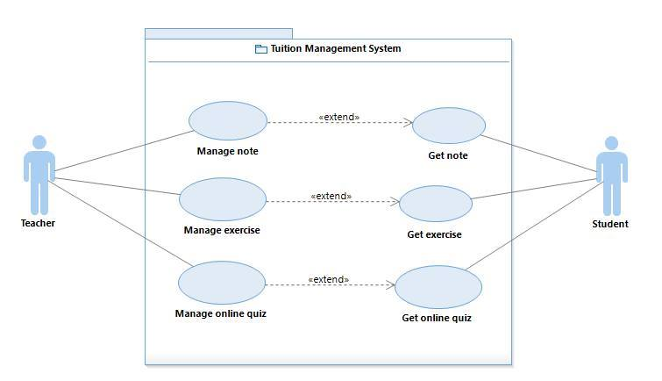

Figure 3.2.1 : Decompose of Use case Manage Teaching Material

Then, each use case (at sea level) in Figure 3.2.1 is describe in Table 3.4, 3.5, 3.6, 3.7, 3.8 and 3.9.

**Table 3.4 Manage Note**

|  |  |
| --- | --- |
| **Use Case ID** | UC-TM-01 |
| **Actor** | Teacher |
| **Pre-Conditions** | Teachers need to accesses the tuition website. |
| **Basic Flow** | 1. After teacher login into the system, user should click at the main menu. 2. Teacher will see the specific subject from the list of the subject. 3. Then, teacher will have an option there are to upload, delete or save their notes. |
| **Alternative Flow** | 1.The system will display several options:  A1) Add Note.  A2) Update Note.  A3) Delete Note.  A4) Save Note. |
| **Exception Flow** | 1. The notes cannot be retrieved.  E1) Reload the page  E2) Continue to upload the notes |
| **Post-Conditions** | Teacher successful upload their notes. |
| **Rules** | - |
| **Constraints** | Need check on internet connection. |
| **Activity Diagram**  **(if any)** | Refer in Appendix A  3.1.2 Activity Diagram for Teaching Module |

**Table 3.5 Manage Exercise**

|  |  |
| --- | --- |
| **Use Case ID** | UC-TM-01 |
| **Actor** | Teacher |
| **Pre-Conditions** | Teachers need to accesses the tuition website. |
| **Basic Flow** | 1. After teacher login into the system, user should click at the main menu.  2. Teacher will see the specific subject from the list of the subject.  3. Then, teacher will have an option there are to upload, delete or save their exercises. |
| **Alternative Flow** | 1.The system will display several options:  A1) Add Exercise.  A2) Update Exercise.  A3) Delete Exercise.  A4) Save Exercise. |
| **Exception Flow** | 1.The exercise cannot be retrieved.  E1) Reload the page  E2) Continue to upload the exercises. |
| **Post-Conditions** | Teacher successful upload their exercise. |
| **Rules** | - |
| **Constraints** | Need check on internet connection. |
| **Activity Diagram**  **(if any)** | Refer in Appendix A  3.1.2 Activity Diagram for Teaching Module |

**Table 3.6 Manage Online quiz.**

|  |  |
| --- | --- |
| **Use Case ID** | UC-TM-01 |
| **Actor** | Teacher |
| **Pre-Conditions** | Teachers need to accesses the tuition website. |
| **Basic Flow** | 1. After teacher login into the system, user should click at the main menu.  2. Teacher will see the specific subject from the list of the subject.  3. Then, teacher will choose to open the online quiz for their students. |
| **Alternative Flow** | 1.The system will display several options:  A1) Open online quiz |
| **Exception Flow** | 1. The online quiz can’t be uploading into the system.  E1) Reload the page  E2) Continue to upload the quiz. |
| **Post-Conditions** | Teacher successful open the online quiz for their students. |
| **Rules** | - |
| **Constraints** | Need check on internet connection. |
| **Activity Diagram**  **(if any)** | Refer in Appendix A  3.1.2 Activity Diagram for Teaching Module |

**Table 3.7 Get Note**

|  |  |
| --- | --- |
| **Use Case ID** | UC-TM-01 |
| **Actor** | Student |
| **Pre-Conditions** | Students need to accesses the tuition website. |
| **Basic Flow** | 1. After student login into the system, user should click at the main menu.  2. Student will see the subject that they have register in TMS.  3. Student has to get the notes.  4. Then, student will have an option to download their notes, print their notes or save as PDF. |
| **Alternative Flow** | 1.The system will display several options:  A1) Download note.  A2) Print note.  A3) Save as PDF file. |
| **Exception Flow** | 1. The note can’t be downloading.   E1) Reload the page.  E2) Continue refresh the page. |
| **Post-Conditions** | Student successful get the notes. |
| **Rules** | - |
| **Constraints** | Need check on internet connection. |
| **Activity Diagram**  **(if any)** | Refer in Appendix A  3.1.2 Activity Diagram for Teaching Module |

**Table 3.8 Get Exercise**

|  |  |
| --- | --- |
| **Use Case ID** | UC-TM-01 |
| **Actor** | Student |
| **Pre-Conditions** | Students need to accesses the tuition website. |
| **Basic Flow** | 1. After student login into the system, user should click at the main menu.  2. Student will see the subject that they have register in TMS.  3. Student have to get the exercise  4. Then, student will have an option to download their exercise, print their exercises or save as PDF. |
| **Alternative Flow** | 1.The system will display several options:  A1) Download exercise.  A2) Print exercise.  A3) Save as PDF file. |
| **Exception Flow** | 1. The exercise can’t be downloading.   E1) Reload the page.  E2) Continue refresh the page. |
| **Post-Conditions** | Student successful get the exercise. |
| **Rules** | - |
| **Constraints** | Need check on internet connection. |
| **Activity Diagram**  **(if any)** | Refer in Appendix A  3.1.2 Activity Diagram for Teaching Module |

**Table 3.9 Get quiz online**

|  |  |
| --- | --- |
| **Use Case ID** | UC-TM-01 |
| **Actor** | Student |
| **Pre-Conditions** | Students need to accesses the tuition website. |
| **Basic Flow** | 1. After student login into the system, user should click at the main menu.  2. Student will see the subject that they have register in TMS.  3. Student has to get the online quiz.  4. Then, student will attend the quiz.  5. Submit their answer to the system. |
| **Alternative Flow** | 1.The system will display several options:  A1) Attend quiz.  A2) Submit. |
| **Exception Flow** | 1. The online quiz can’t be attempt in certain time.   E1) Reload the page.  E2) Continue refresh the page. |
| **Post-Conditions** | Student successful get the online quiz. |
| **Rules** | Student need to answer the quiz with specific time. |
| **Constraints** | Need check on internet connection. |
| **Activity Diagram**  **(if any)** | Refer in Appendix A  3.1.2 Activity Diagram for Teaching Module |

### 3.1.3 Registration Module Use Case.

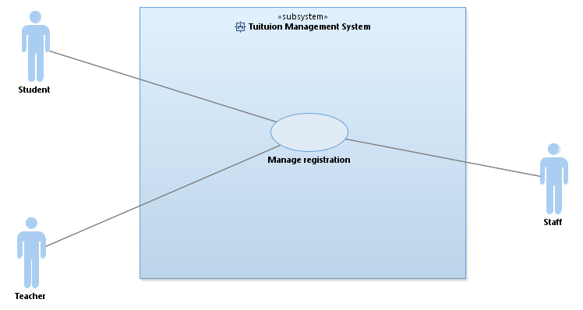

Figure 3.3: Use case for Manage registration

This use case diagram shows the actor that use the sub system in the TMS. The actor use the manage registration such as student will register to the tuition centre system and register the subject. The teacher will use the manage registration to register the subject they want to teach.

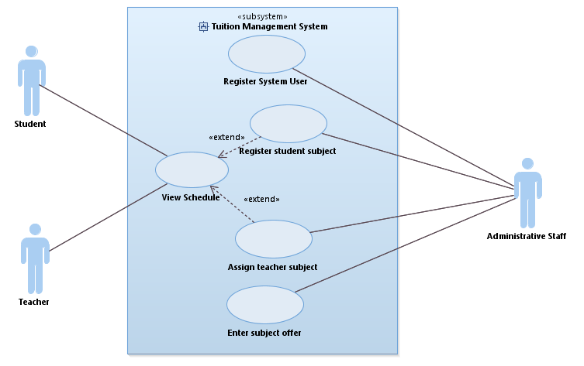

Figure 3.3.1: Decompose use case Registration Module

Then, each use case (at sea level) in Figure 3.3.1 is describe in Table 3.1, 3.11, 3.12, 3.13 and 3.14.

**Table 3.10 Use Case Register System User**

|  |  |
| --- | --- |
| **Use Case ID** | UC-RM-01 |
| **Brief Description** | In this use case, administrative staff should register new user of the system either new student, new staff or new teacher. |
| **Actor** | Staff |
| **Pre-Conditions** | For staff to register the system user, staffs need to login the webpage first. |
| **Basic Flow** | 1. Staffs choose either to register new student, new staff or new teacher. 2. Staffs enter the information needed in space provided. 3. Staffs save the information by clicking save button. |
| **Alternative Flow** | Three option for register system user:   1. Register new student 2. Register new staff 3. Register new teacher |
| **Exception Flow** | 1. Submit button not functioning.    1. Reload the page    2. Enter information    3. Click submit button |
| **Post-Conditions** | User successfully saved the data into the database. |
| **Rules** | - |
| **Constraints** | Must have an internet connection or connection that connected to server. |
| **Activity Diagram**  **(if any)** | Refer in Appendix A  A3 Activity Diagram for Registration Module |

**Table 3.11 Use Case Register Student’s Subject**

|  |  |
| --- | --- |
| **Use Case ID** | UC-RM-02 |
| **Brief Description** | In this use case, staffs need to register student’s subject in the request of the student, parent of student or the guardian of the student. |
| **Actor** | Staff |
| **Pre-Conditions** | For staff to register the system user, staffs need to login the webpage first. |
| **Basic Flow** | 1. Staff choose the student id 2. Staff choose the subject 3. Staff save the information by clicking the save button. |
| **Alternative Flow** | The system give two option:   1. Save the information 2. Cancel information entered |
| **Exception Flow** | 1. Submit button not functioning.    1. Reload the page    2. Choose Subject    3. Click submit button |
| **Post-Conditions** | Information is saved. |
| **Rules** | - |
| **Constraints** | Must have an internet connection. |
| **Activity Diagram**  **(if any)** | Refer in Appendix A  A3 Activity Diagram for Registration Module |

**Table 3.12 Use Case Assign Teacher Subject**

|  |  |
| --- | --- |
| **Use Case ID** | UC-RM-03 |
| **Brief Description** | In this use case, staffs need to register the subject for the teacher to teach according to their job scope. |
| **Actor** | Staff |
| **Pre-Conditions** | For staff to register the system user, staffs need to login the webpage first. |
| **Basic Flow** | 1. Staff choose the teacher id 2. Staff choose the subject 3. Staff save the information by clicking the save button. |
| **Alternative Flow** | The system give two option:   1. Save the information 2. Cancel information entered |
| **Exception Flow** | Submit button not functioning.   1. Reload the page 2. Choose Subject 3. Click submit button |
| **Post-Conditions** | Information is saved. |
| **Rules** | - |
| **Constraints** | Must have an internet connection. |
| **Activity Diagram**  **(if any)** | Refer in Appendix A  A3 Activity Diagram for Registration Module |

**Table 3.13 Use Case Enter Subject Offer**

|  |  |
| --- | --- |
| **Use Case ID** | UC-RM-04 |
| **Brief Description** | In this use case, staffs need to register the subject to offer to the student according to the head of tuition centre. |
| **Actor** | Staff |
| **Pre-Conditions** | For staff to register the system user, staffs need to login the webpage first. |
| **Basic Flow** | 1. Staff choose the subject code 2. Staff enter the subject 3. Staff save the information by clicking the save button. |
| **Alternative Flow** | The system give two option:   1. Save the information 2. Cancel information entered |
| **Exception Flow** | Submit button not functioning.   1. Reload the page 2. Enter subject 3. Click submit button |
| **Post-Conditions** | Information is saved. |
| **Rules** | - |
| **Constraints** | Must have an internet connection. |
| **Activity Diagram**  **(if any)** | Refer in Appendix A  A3 Activity Diagram for Registration Module |

**Table 3.14 Use Case View Schedule**

|  |  |
| --- | --- |
| **Use Case ID** | UC-RM-05 |
| **Brief Description** | In this use case, student and teacher can view their schedule. |
| **Actor** | Student and teacher |
| **Pre-Conditions** | For student and teacher to view their schedule, they need to login the webpage first. |
| **Basic Flow** | Student and teacher click button view schedule. |
| **Alternative Flow** | The system give two option:   1. Print schedule 2. Download schedule |
| **Exception Flow** | Schedule did not come out.   1. Reload the page |
| **Post-Conditions** | Schedules appear. |
| **Rules** | - |
| **Constraints** | Must have an internet connection. |
| **Activity Diagram**  **(if any)** | Refer in Appendix A  A3 Activity Diagram for Registration Module |

### 3.1.4 Student Performance Module Use Case

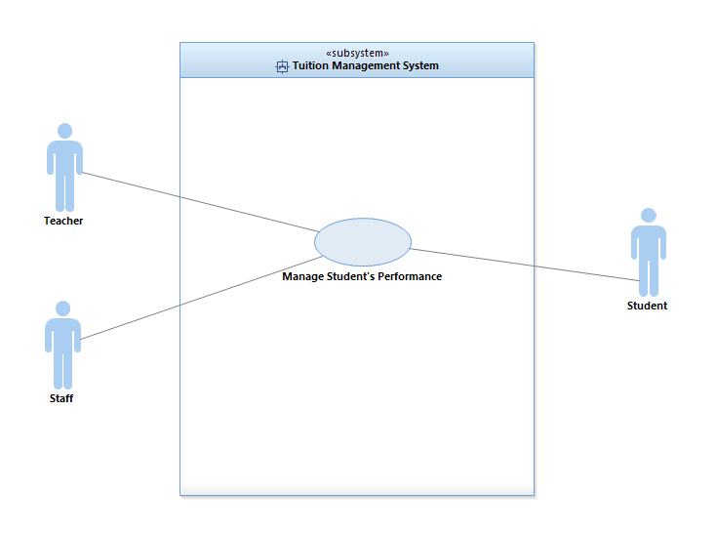

Figure 3.4:Use case for Student’s Performance

This use case diagram shows the actors that use the sub system in the TMS. The actor use the manage student performance such as student will view their result and comment from teacher. The teacher will use the manage student performance to enter student result and give comment on them.

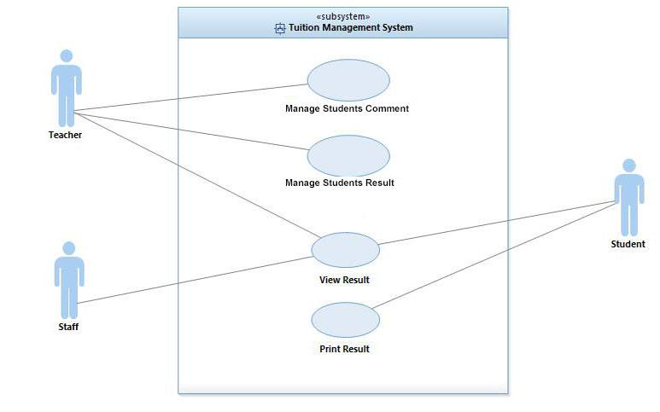

Figure 3.4.1: Decompose use case Student’s Performance Module

Then, each use case (at sea level) in Figure 3.4.1 is describe in Table 3.15, 3.16, 3.17 and 3.18

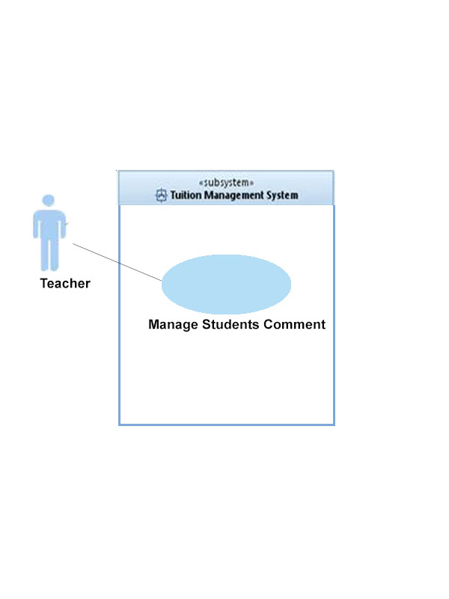

**Table 3.15 Use Case Manage Student’s Comment**

|  |  |
| --- | --- |
| **Use Case ID** | UC-PM-01 |
| **Brief Description** | In this use case, users are able to manage comment to students. |
| **Actor** | Teacher. |
| **Pre-Conditions** | Login to system and button “Comment” is clicked. |
| **Basic Flow** | * + - 1. Teacher can give comment to their student.       2. Teacher can save comment to student. |
| **Alternative Flow** | Teacher clicked the button comment.   1. Teacher clicked the comment button to give comment to student |
| **Exception Flow** | - |
| **Post-Conditions** | Teacher can give comment to student |
| **Rules** | Teacher need to access the system before they can make any comment about their students. |
| **Constraints** | Must have an internet connection. |
| **Activity Diagram**  **(if any)** | Refer in Appendix A  A4 Activity Diagram for Student’s Performance Module |

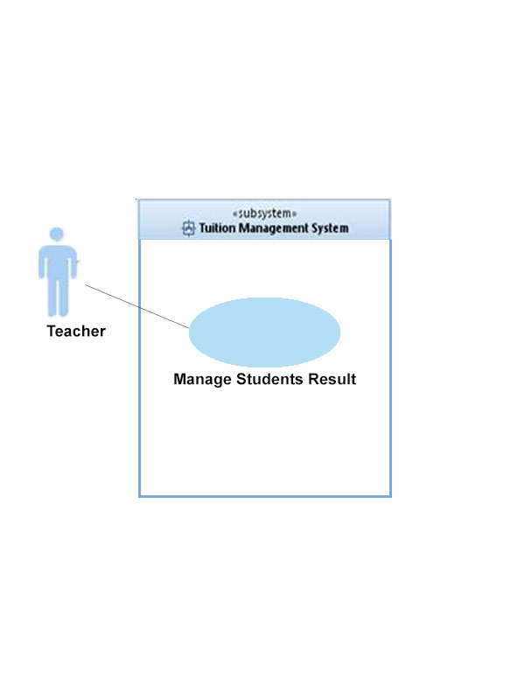

**Table 3.16 Use Case Manage Student’s Result**

|  |  |
| --- | --- |
| **Use Case ID** | UC-PM-02 |
| **Brief Description** | In this use case, teachers are able to manage student result. |
| **Actor** | Teacher. |
| **Pre-Conditions** | Teacher need to log in into the system and clicked button “student result”. |
| **Basic Flow** | 1. Teacher will see the list of student and can insert result of students. |
| **Alternative Flow** | 1. Click button result.  A) Teacher can insert result of student  B) System will save student’s result. |
| **Exception Flow** | - |
| **Post-Conditions** | Data will store to database. |
| **Rules** |  |
| **Constraints** | Must have an internet connection. |
| **Activity Diagram**  **(if any)** | Refer in Appendix A  A4 Activity Diagram for Student’s Performance Module |

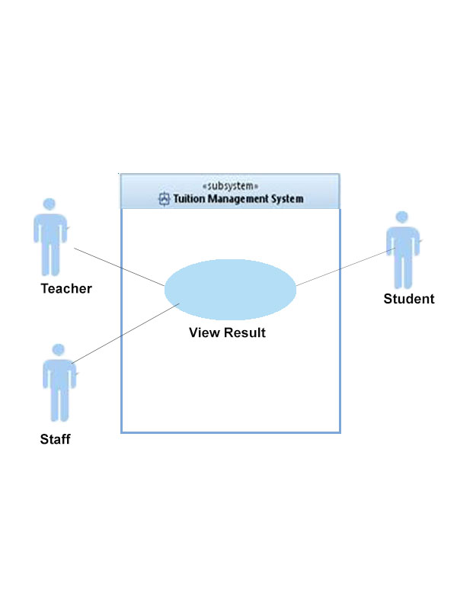

**Table 3.17 Use Case View Result**

|  |  |
| --- | --- |
| **Use Case ID** | UC-PM-03 |
| **Brief Description** | In this use case, users are able to view the result that teacher key-in into the system. |
| **Actor** | Teacher, student, staff |
| **Pre-Conditions** | Login to system and clicked button “student result” |
| **Basic Flow** | 1. User can see the student result. |
| **Alternative Flow** | 1.User click the “student result” button  A) User clicked button student result to view result.  B) Result will display |
| **Exception Flow** | - |
| **Post-Conditions** | The result will be display. |
| **Rules** | - |
| **Constraints** | Must have an internet connection. |
| **Activity Diagram**  **(if any)** | Refer in Appendix A  A4 Activity Diagram for Student’s Performance Module |

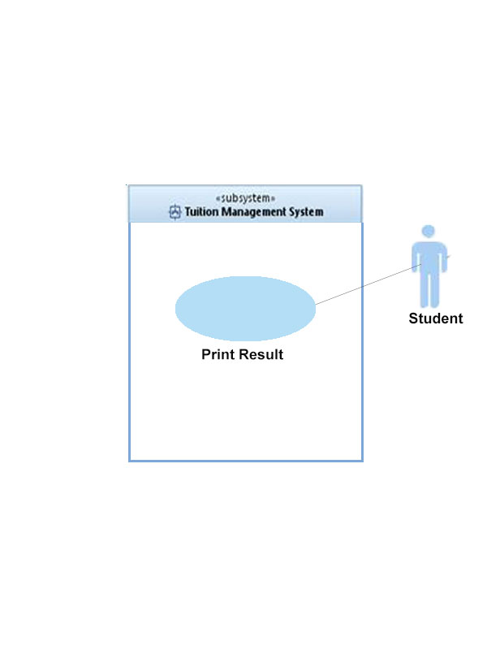

**Table 3.18 Use Case Print Result.**

|  |  |
| --- | --- |
| **Use Case ID** | UC-PM-04 |
| **Brief Description** | In this use case, users are print the result |
| **Actor** | Student |
| **Pre-Conditions** | Login to system and clicked button “print”. |
| **Basic Flow** | 1. Student will see the result. 2. Student is allow to click button print to print the result. |
| **Alternative Flow** | User click at the button print   1. User click button print to print result 2. The result will printed. |
| **Exception Flow** | - |
| **Post-Conditions** | - |
| **Rules** | - |
| **Constraints** | No need internet connection. |
| **Activity Diagram**  **(if any)** | Refer in Appendix A  A4 Activity Diagram for Student’s Performance Module |

### 3.1.5 Attendance Module Use Case.

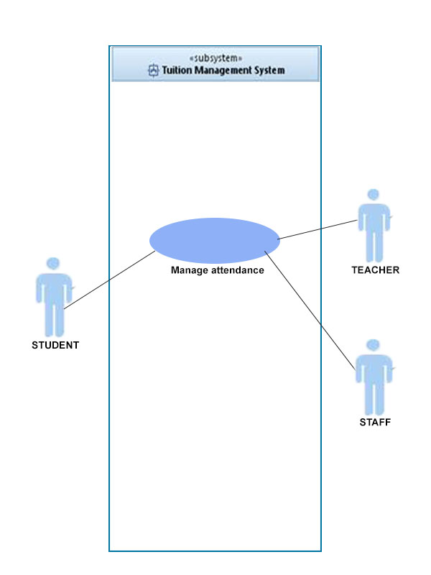

Figure 3.5: Use case for Manage Attendance

This use case diagram shows the actors that use the sub system in the TMS. The actor use the manage attendance such as student record their attendance to class. The teacher and staff will use the manage attendance to record themselves for work.

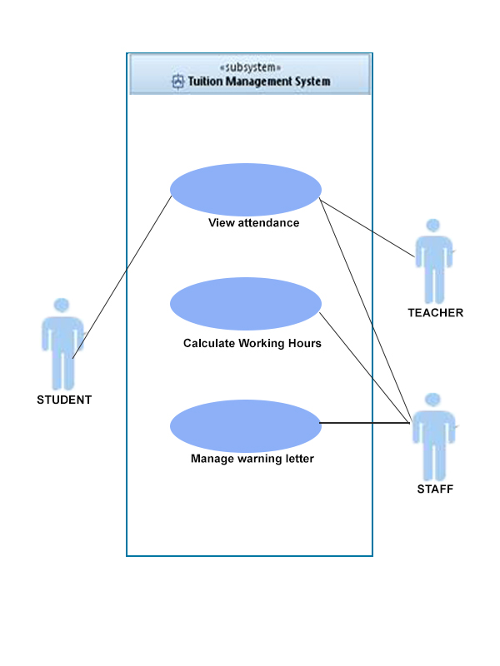

Figure 3.5.1: Decompose of Use case Manage Attendance

Then, each use case (at sea level) in Figure 3.5. is describe in Table 3.19, 3.20 and 3.21

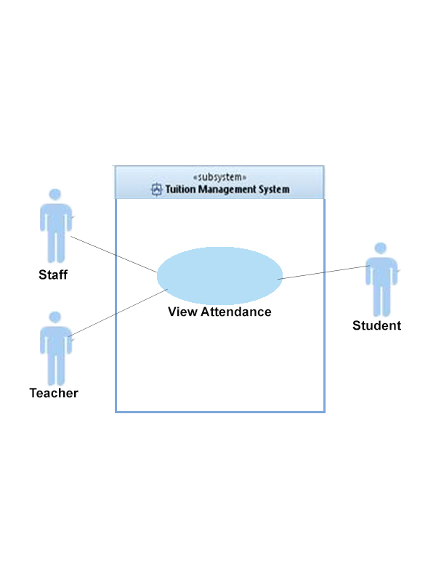

**Table 3.19 Use Case View Attendance**

|  |  |
| --- | --- |
| **Use Case ID** | UC-AM-01 |
| **Brief Description** | In this use case, users are able to view the attendance that they attend. |
| **Actor** | Teacher, student, staff |
| **Pre-Conditions** | Login into the system and ‘Attendance’ button is clicked |
| **Basic Flow** | Staff  1.Staff must select name, subject and month to view all attendance that they attend..  2.Submit the information that are selected.  3.Student details will appear at screen.  Teacher  1.Teacher must select their subject and month.  2.Submit the information.  3.Will display their attendance for month and subject she/he selected that they attend.  Student  1.Student must select their subject and month.  2.Submit the information.  3.Will display their attendance for month and subject she/he selected that they attend. |
| **Alternative Flow** | 1.User click the month button  A) User click the month button  B) User must select which moth and subject they want to see.  C) Will display attendance for the month and subject. |
| **Exception Flow** | Submit button not functioning.  1.Reload the page  2.Choose Subject and Month.  Click submit button |
| **Post-Conditions** | - |
| **Rules** | -User have login to Tuition Centre. |
| **Constraints** | Must have an internet connection. |
| **Activity Diagram**  **(if any)** | Refer in Appendix A  A5 Activity Diagram for Attendance Module |

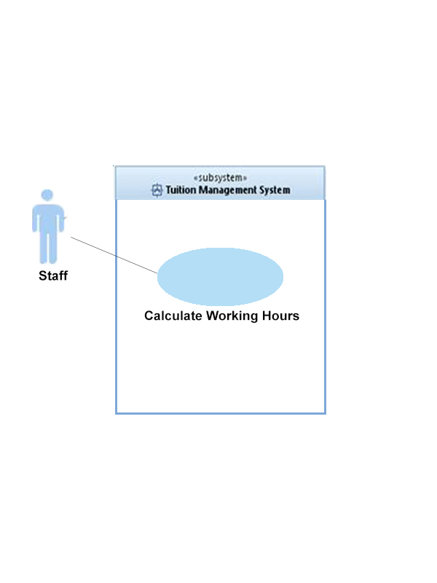

**Table 3.20 Use Case Calculate Working Hours**

|  |  |
| --- | --- |
| **Use Case ID** | UC-AM-02 |
| **Brief Description** | In this use case, staff will calculate working hours for all teacher and staff. |
| **Actor** | Staff |
| **Pre-Conditions** | Login to system |
| **Basic Flow** | 1. Staffs have to select teachers name, subject and month. 2. Click button “Calculate”. 3. Will displays hours that teacher working for the month and subject. |
| **Alternative Flow** | Submit button not functioning.  1.Reload the page  2.Choose name, subject and month.  Click submit button |
| **Exception Flow** | - |
| **Post-Conditions** | -The information will be transfer to the finance department. |
| **Rules** | -User have to login to Tuition Centre. |
| **Constraints** | Must have an internet connection. |
| **Activity Diagram**  **(if any)** | Refer in Appendix A  A5 Activity Diagram for Attendance Module |

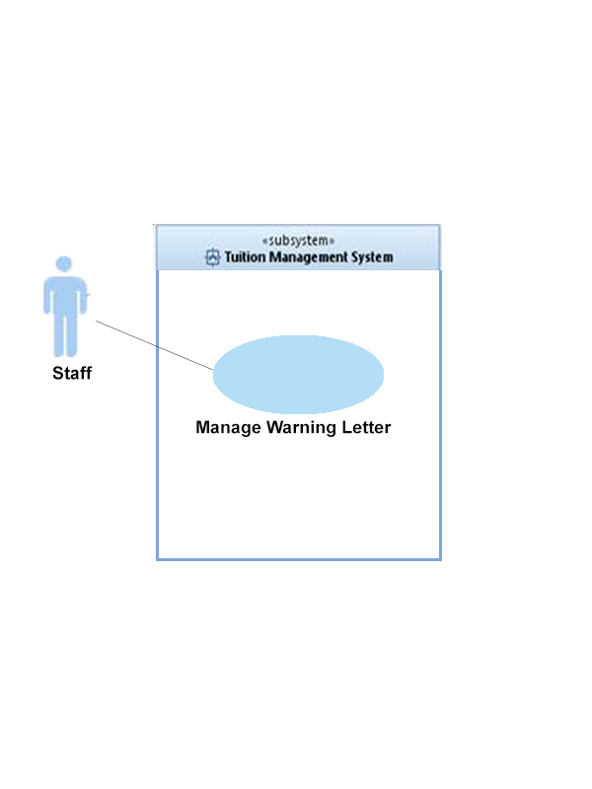

**Table 3.21 Use Case Manage Warning Letter**

|  |  |
| --- | --- |
| **Use Case ID** | UC-AM-03 |
| **Brief Description** | In this use case, staff will distributed warning letter depend on more than 3 times student are not absent to the class. |
| **Actor** | Staff |
| **Pre-Conditions** | Login to system |
| **Basic Flow** | 1. Staff should to login, after that, go to warning letter. 2. Staffs have to select ‘month’, and ‘subject’. 3. System will view all students which are not absent more than 3 times. 4. Staff has to click ‘print’ to print all the letters on the names of every student who is absent. |
| **Alternative Flow** | Submit button not functioning.  1.Reload the page  2.Choose subject and month.  Click submit button |
| **Exception Flow** | - |
| **Post-Conditions** | Print the letter. |
| **Rules** | Students are absent more than 3 times. |
| **Constraints** | Must have an internet connection. |
| **Activity Diagram**  **(if any)** | Refer in Appendix A  A5 Activity Diagram for Attendance Module |

## 3.2 User Interfaces Requirements

3.2.1 Graphical User Interface

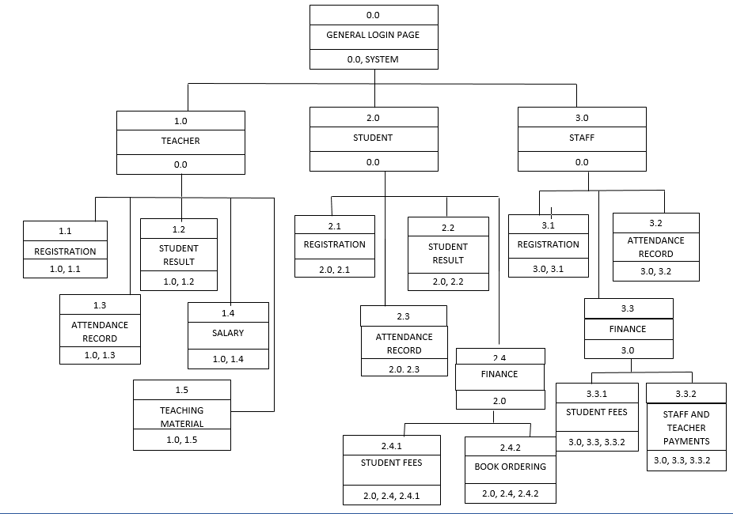

**Figure 3.6:Dialog Diagram for Tuition Management System.**

**Table 3.22 Description of user interface components**

|  |  |
| --- | --- |
| **Page** | **Description** |
| Home Page | This homepage provide interface for general website such as page home, package, about us and contact us. User need to login in the system to use this system. |
| User Registration | Admin have 3 choices which is button registration new student, registration new teacher and registration new staff to register user of the system. |
| Subject Registration | Admin have 3 choices which is button student subject, teacher subject and subject offer to register subject of students and teachers. |
| Teaching Module | This page provide user with contain of notes for every subject. User can choose any subject they want in the list at the page. |
| Note Page | Student can download, make quiz and read announcement at the page. |
| Fees Homepage | Button fees will display student fee regarding which subject they take and button print enroll student to print the slip. |
| Book Ordering Page | Button ordering book will display list of the book regarding student’s order. |
| Payment Page | Button payment will display to teacher about their payment of the month regarding how many hours they work. |
| Student Result Page | When user clicked button result, system will show their result. |
| Attendance Page | When teacher and student clicked on the button attendance, system will show their attendance regarding on month they select to show. |

3.7 Graphical User Interface

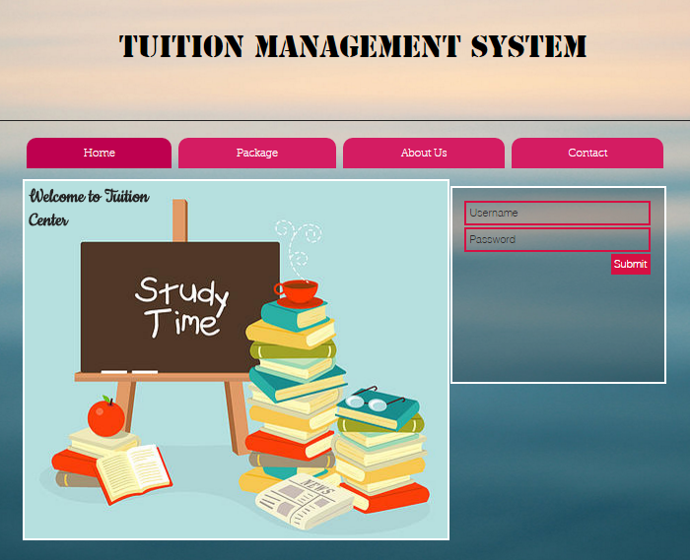

Figure 3.7.1: Home Page

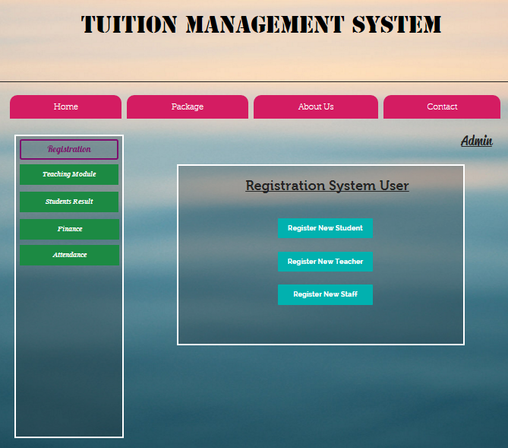

Figure 3.7.2: User Registration

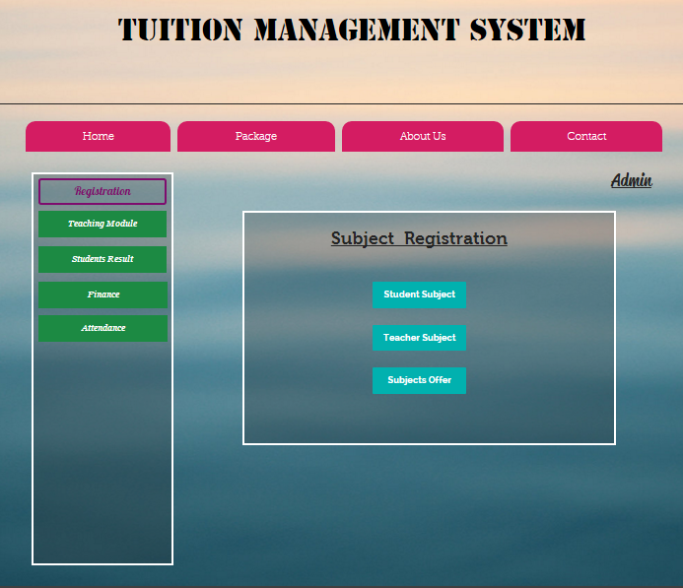

Figure .7.3: Subject Registration

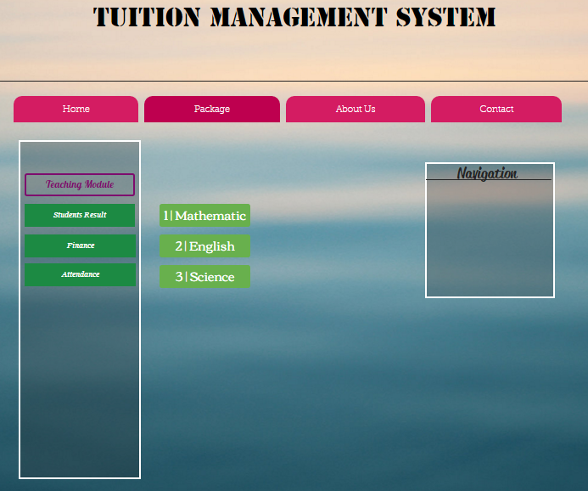

Figure3.7.4: Teaching Module

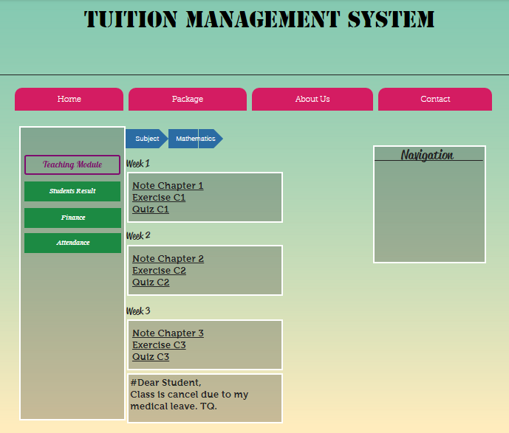

Figure 3.7.5: Note Page

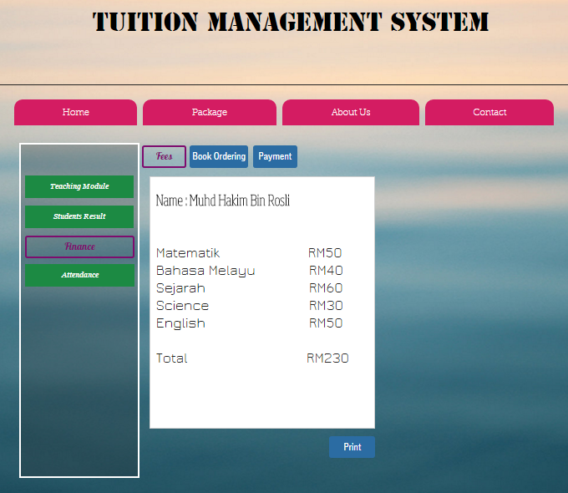

Figure 3.7.3: Fees Homepage

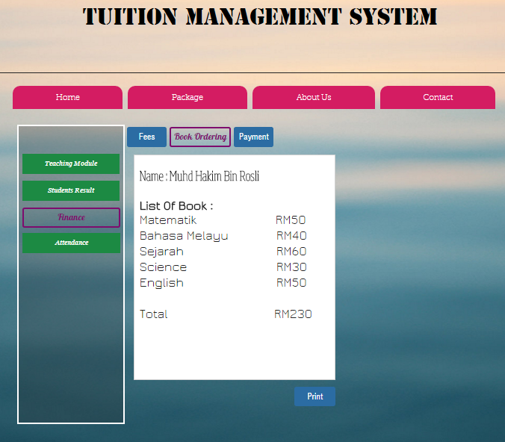

Figure 3.7.4: Book Ordering Page

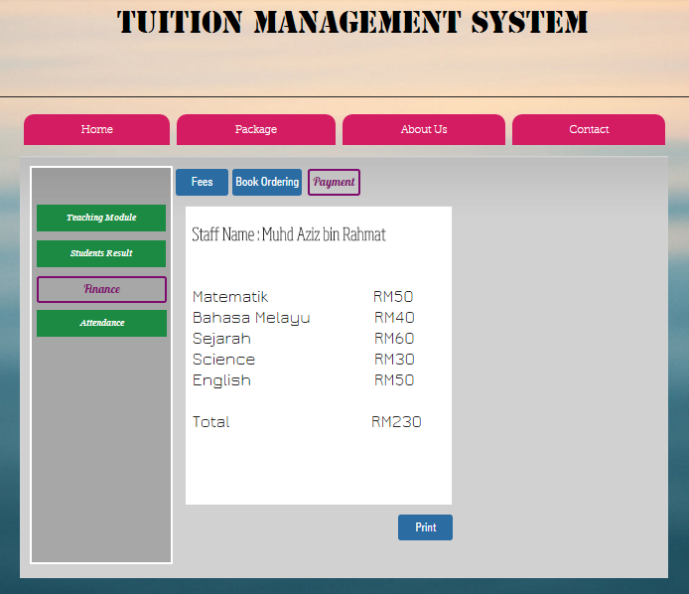

Figure 3.7.5: Payment Page

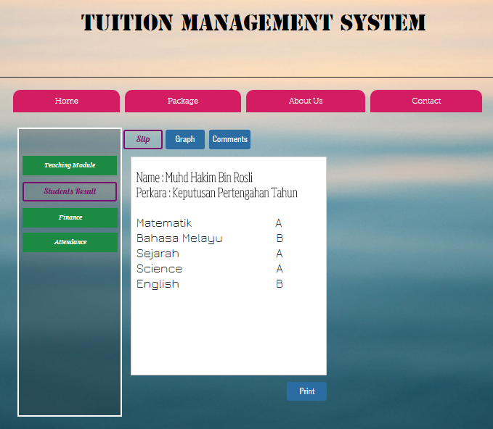

Figure 3.7. : Student Result Page

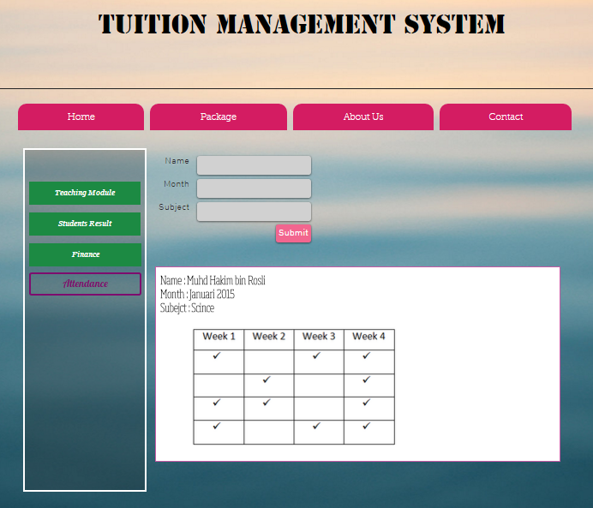

Figure 3.7.7: Attendance Page

3.2.2 Hardware Interface

1. BIOSYSTEM Punch Card Machine BX2000D for record attendance staff, student and teacher.
2. ATM System for students pay fee to tuition center and teachers withdraw money.

3.2.3 Software Interface

1. Mozilla, Chrome and Internet Explorer for browse the portal of Tuition Management System.
2. Oracle Database 11g Express Edition for development database.
3. NetBeans IDE 8.0 for developing system with use java language.

**3.3 Requirements Traceability**

**Table 3.23: Traceability matrix for a**

|  |  |  |  |  |  |  |  |  |  |  |  |  |  |  |  |  |  |
| --- | --- | --- | --- | --- | --- | --- | --- | --- | --- | --- | --- | --- | --- | --- | --- | --- | --- |
| Use Case  Requirement Id | UC-RM-01 | UC-RM-02 | UC-RM-03 | UC-RM-04 | UC-RM-05 | UC-TM-01 | UC-TM-02 | UC-TM-03 | UC-TM-04 | UC-VA-01 | UC-CWH-02 | UC-AM-03 | UC-PM-01 | UC-PM-03 | UC-PM-04 | UC-FM-01 | UC-FM-03 |
| SFR-RM-01 |  |  |  |  |  |  |  |  |  |  |  |  |  |  |  |  |  |
| SFR-RM-02 |  |  |  |  |  |  |  |  |  |  |  |  |  |  |  |  |  |
| SFR-RM-03 |  |  |  |  |  |  |  |  |  |  |  |  |  |  |  |  |  |
| SFR-RM-04 |  |  |  |  |  |  |  |  |  |  |  |  |  |  |  |  |  |
| SFR-RM-05 |  |  |  |  |  |  |  |  |  |  |  |  |  |  |  |  |  |
| SFR-RM-06 |  |  |  |  |  |  |  |  |  |  |  |  |  |  |  |  |  |
| SFR-TM-01 |  |  |  |  |  |  |  |  |  |  |  |  |  |  |  |  |  |
| SFR-TM-02 |  |  |  |  |  |  |  |  |  |  |  |  |  |  |  |  |  |
| SFR-TM-03 |  |  |  |  |  |  |  |  |  |  |  |  |  |  |  |  |  |
| SFR-TM-04 |  |  |  |  |  |  |  |  |  |  |  |  |  |  |  |  |  |
| SFR-TM-05 |  |  |  |  |  |  |  |  |  |  |  |  |  |  |  |  |  |
| SFR-TM-06 |  |  |  |  |  |  |  |  |  |  |  |  |  |  |  |  |  |
| SFR-AM-01 |  |  |  |  |  |  |  |  |  |  |  |  |  |  |  |  |  |
| SFR-AM-02 |  |  |  |  |  |  |  |  |  |  |  |  |  |  |  |  |  |
| SFR-AM-03 |  |  |  |  |  |  |  |  |  |  |  |  |  |  |  |  |  |
| SFR-AM-04 |  |  |  |  |  |  |  |  |  |  |  |  |  |  |  |  |  |
| SFR-AM-05 |  |  |  |  |  |  |  |  |  |  |  |  |  |  |  |  |  |
| SFR-PM-01 |  |  |  |  |  |  |  |  |  |  |  |  |  |  |  |  |  |
| SFR-PM-02 |  |  |  |  |  |  |  |  |  |  |  |  |  |  |  |  |  |
| SFR-PM-03 |  |  |  |  |  |  |  |  |  |  |  |  |  |  |  |  |  |
| SFR-PM-04 |  |  |  |  |  |  |  |  |  |  |  |  |  |  |  |  |  |
| SFR-PM-05 |  |  |  |  |  |  |  |  |  |  |  |  |  |  |  |  |  |
| SFR-PM-06 |  |  |  |  |  |  |  |  |  |  |  |  |  |  |  |  |  |
| SFR-PM-07 |  |  |  |  |  |  |  |  |  |  |  |  |  |  |  |  |  |
| SFR-FM-01 |  |  |  |  |  |  |  |  |  |  |  |  |  |  |  |  |  |
| SFR-FM-02 |  |  |  |  |  |  |  |  |  |  |  |  |  |  |  |  |  |
| SFR-FM-03 |  |  |  |  |  |  |  |  |  |  |  |  |  |  |  |  |  |

**Table 3.24: Traceability matrix for b**

|  |  |
| --- | --- |
| **Use Case Diagram** | **GUI Component** |
| Use Case Registration Module | * Registration page * Subject Registration Page |
| Use Case Teaching Module | * Teaching Module Page * Note Page |
| Use Case Students’ Performance Module | * Student Result Page |
| Use Case Finance Module | * Fees Homepage * Book Ordering Page * Payment Page |
| Use Case Attendance Module | * Attendance Page |

# 4. ACRONYMS AND ABBREVIATION

Table 4.1 : Acronyms and abbreviation in SRS

|  |  |
| --- | --- |
| **Term** | **Definition** |
| TMS | Tuition Management System |
| SRS | Software Requirements Specification |
| SDP | Software Development Plan |
| PHP | PHP: Hypertext Preprocessor |
| SFR | System functional requirement |
| SNR | System non-functional requirement |
| UC | Use case |
| RM | Registration Module |
| PM | Performance Module |
| FM | Finance Module |
| AM | Attendance Module |
| TM | Teaching Module |

**APPENDIX A**

**Activity diagram**

APPENDIX A1

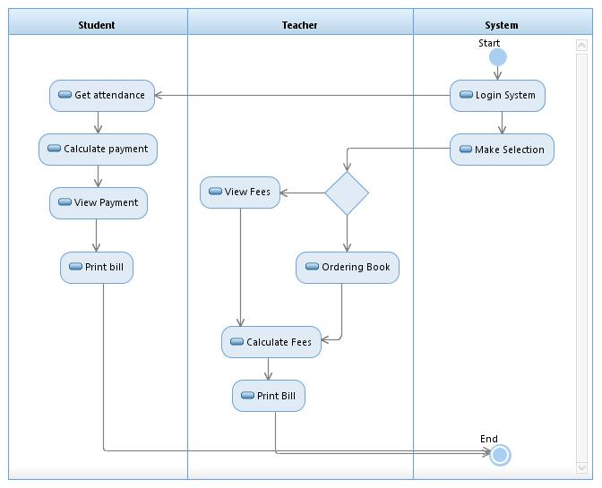

Appendix A-1 Activity Diagram for Financial Module

APPENDIX A2

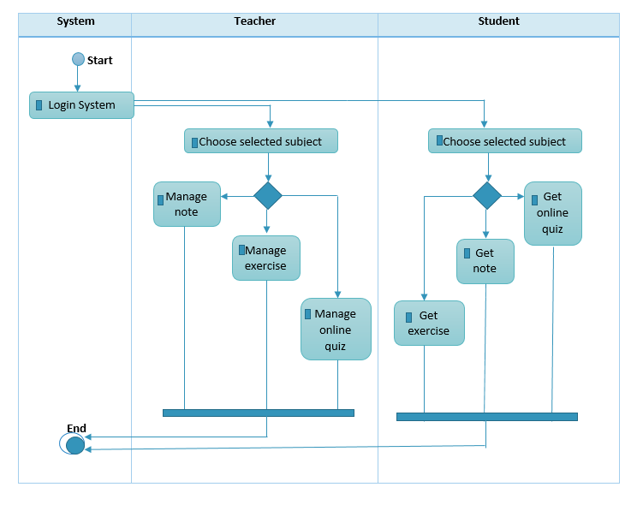

Appendix A-2 Activity Diagram Teaching Module

APPENDIX A3

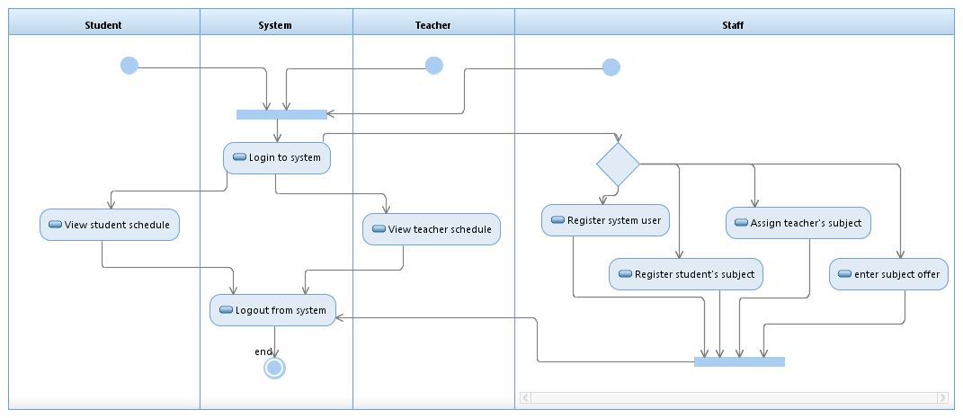

Appendix A-3 Activity Diagram for Registration Module

APPENDIX A4

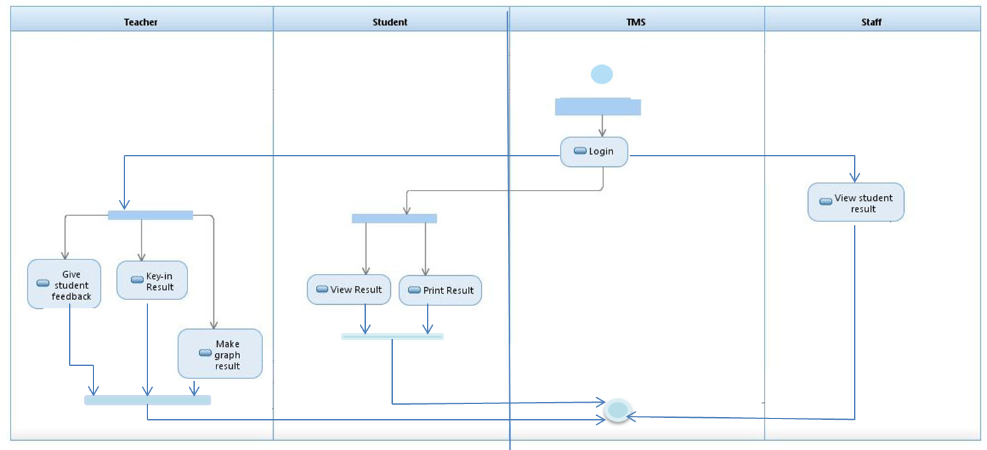

Appendix A-4 Activity Diagram for Student Performance Module

APPENDIX A5

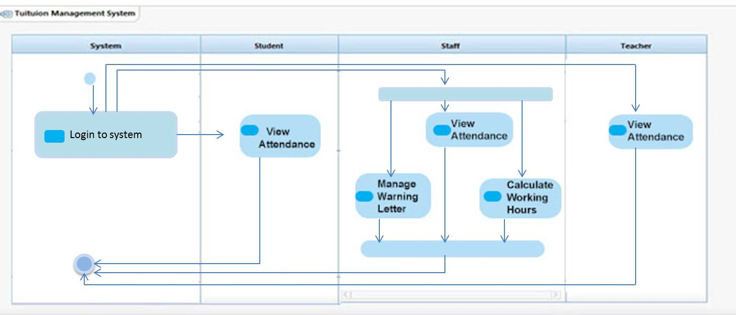

Appendix A-5 Activity Diagram for Attendance Module